Barometer
# Source: AI Source: Provided by: [Data Path: Persons Table -> ID Column: 1, Name_En Column: Motasem Essam] -> From: [ChatGPT] on [7/17/2026]
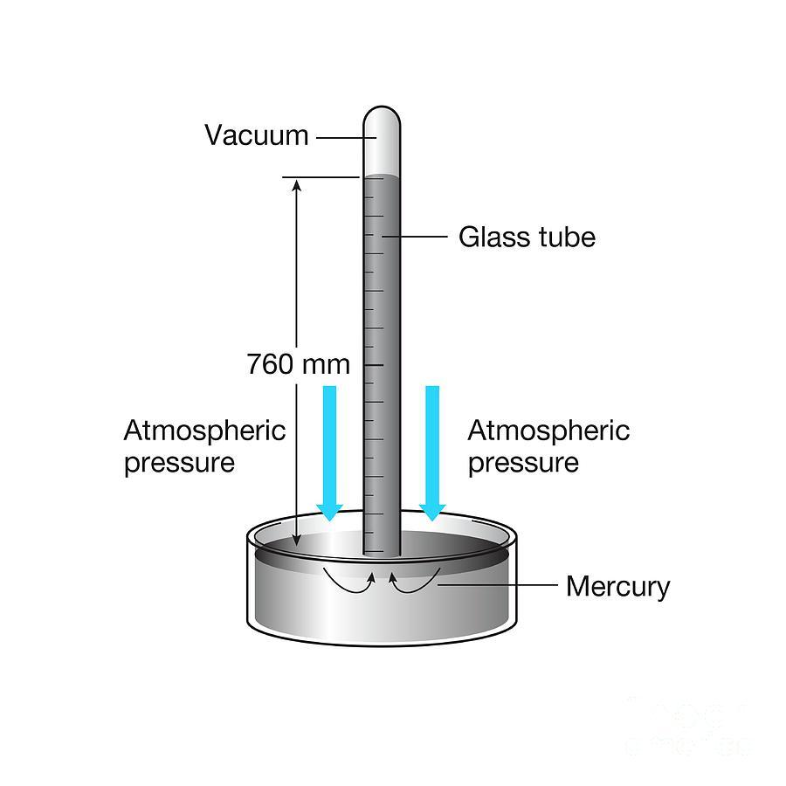
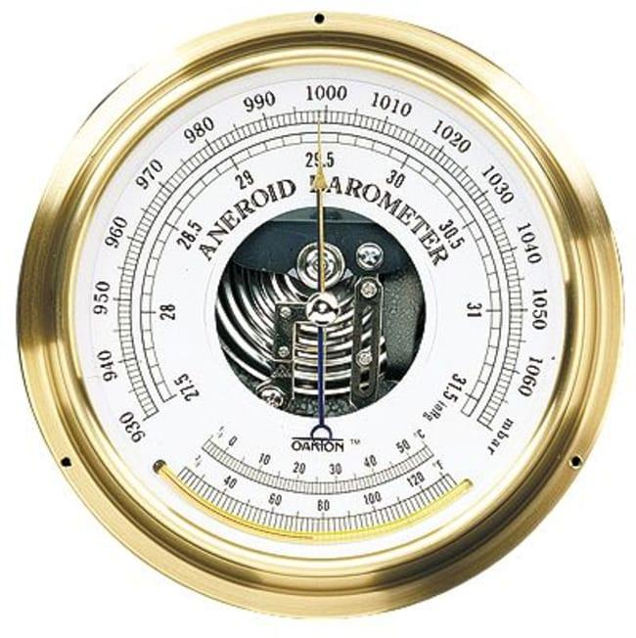
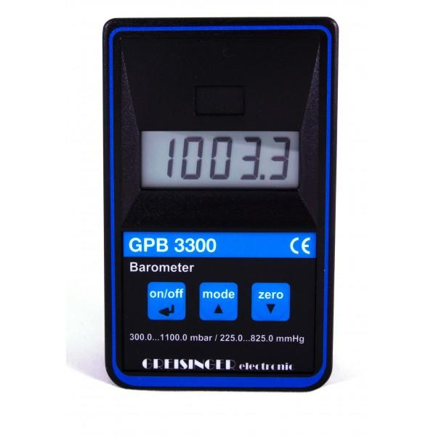
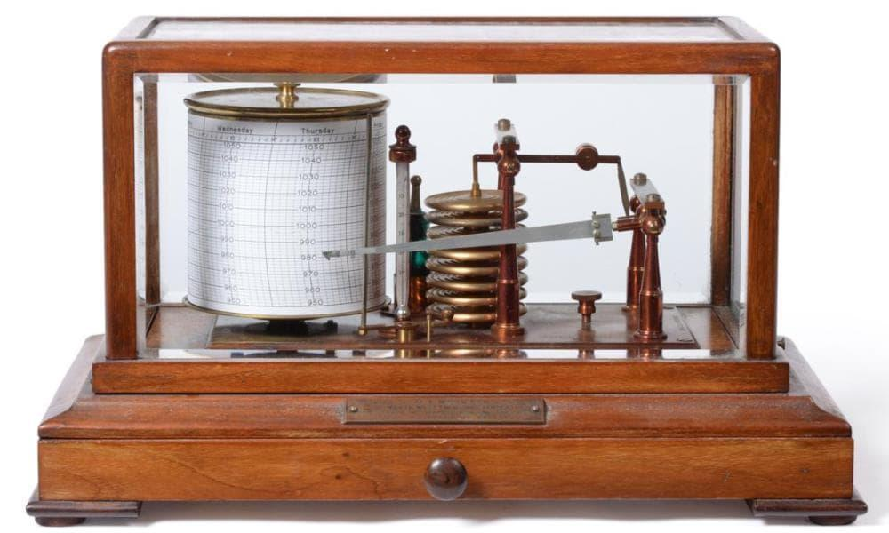
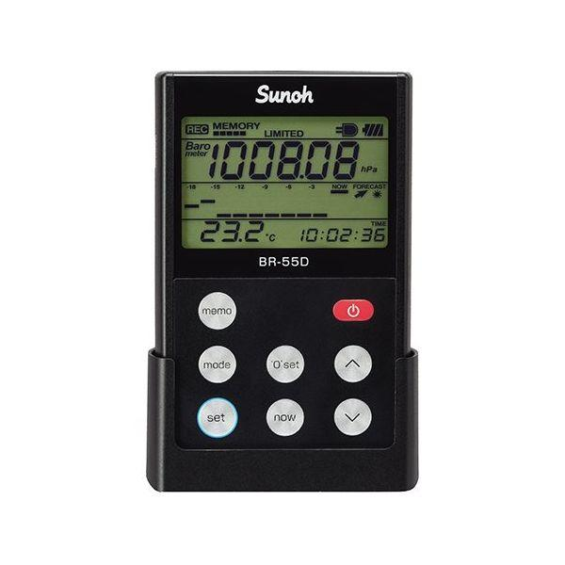
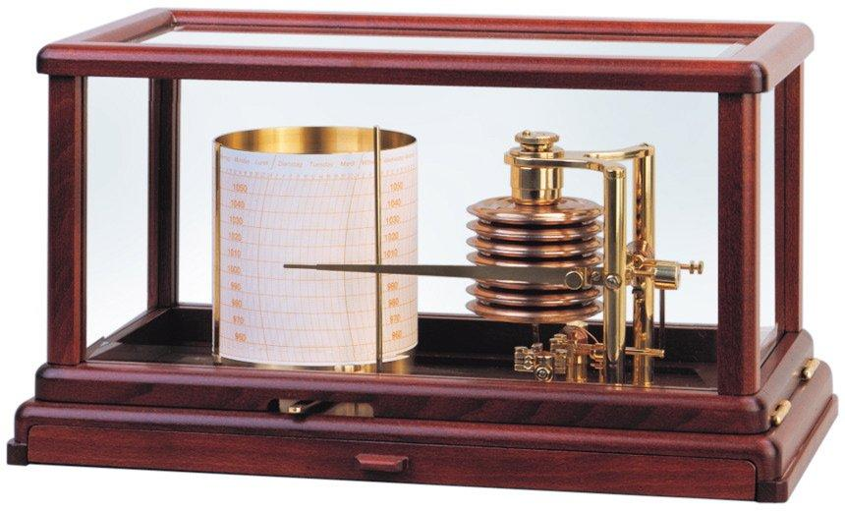
A Barometer is a scientific instrument used to measure atmospheric pressure (air pressure). It is widely used in meteorology, aviation, environmental monitoring, laboratories, and altitude estimation.
Changes in atmospheric pressure help predict weather conditions and determine altitude above sea level.

Definition
# Source: AI Source: Provided by: [Data Path: Persons Table -> ID Column: 1, Name_En Column: Motasem Essam] -> From: [ChatGPT] on [7/17/2026]
A Barometer is an instrument that measures the pressure exerted by the Earth's atmosphere.

Purpose
# Source: AI Source: Provided by: [Data Path: Persons Table -> ID Column: 1, Name_En Column: Motasem Essam] -> From: [ChatGPT] on [7/17/2026]
A barometer is used to:
- Measure atmospheric pressure.
- Forecast weather changes.
- Estimate altitude.
- Monitor environmental conditions.
- Support aviation and meteorology.

Principle of Operation
# Source: AI Source: Provided by: [Data Path: Persons Table -> ID Column: 1, Name_En Column: Motasem Essam] -> From: [ChatGPT] on [7/17/2026]
A barometer measures the pressure exerted by the surrounding atmosphere.
- Mercury barometers balance atmospheric pressure against the height of a mercury column.
- Aneroid barometers measure pressure by the deformation of a sealed metallic capsule.
- Digital barometers use electronic pressure sensors to convert atmospheric pressure into electrical signals.

Main Components
# Source: AI Source: Provided by: [Data Path: Persons Table -> ID Column: 1, Name_En Column: Motasem Essam] -> From: [ChatGPT] on [7/17/2026]
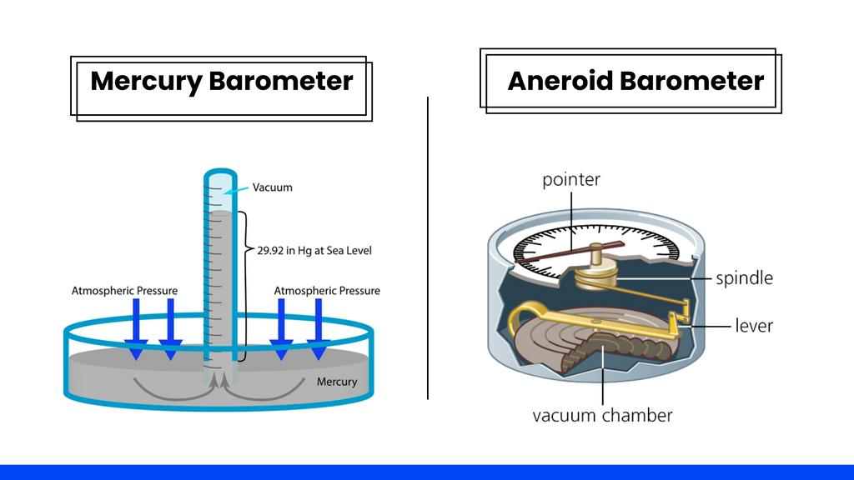
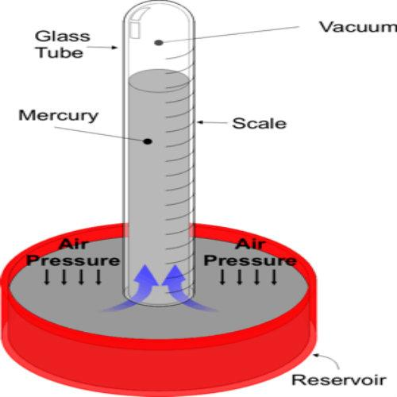
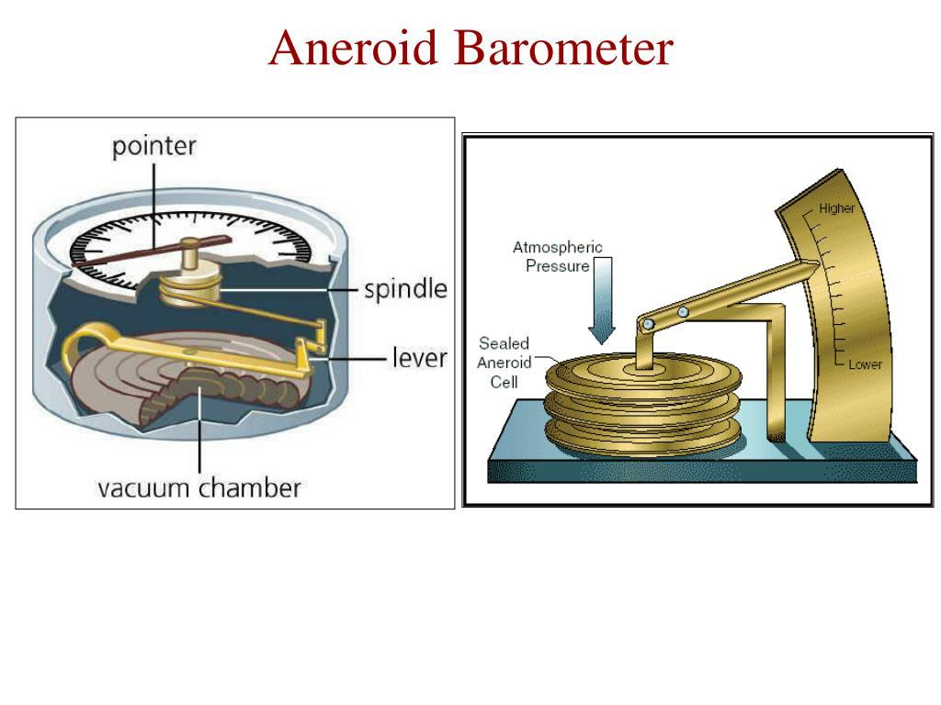
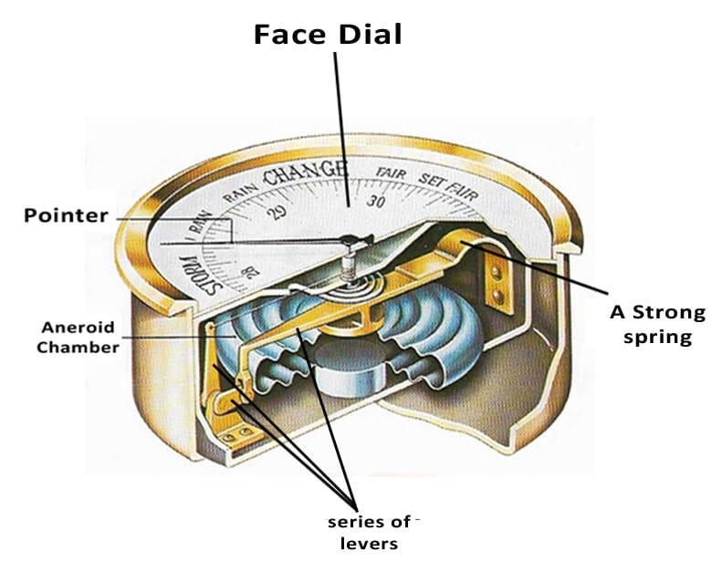
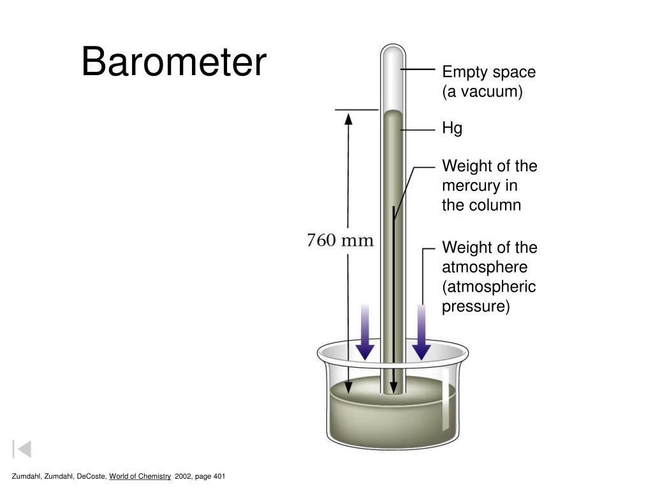
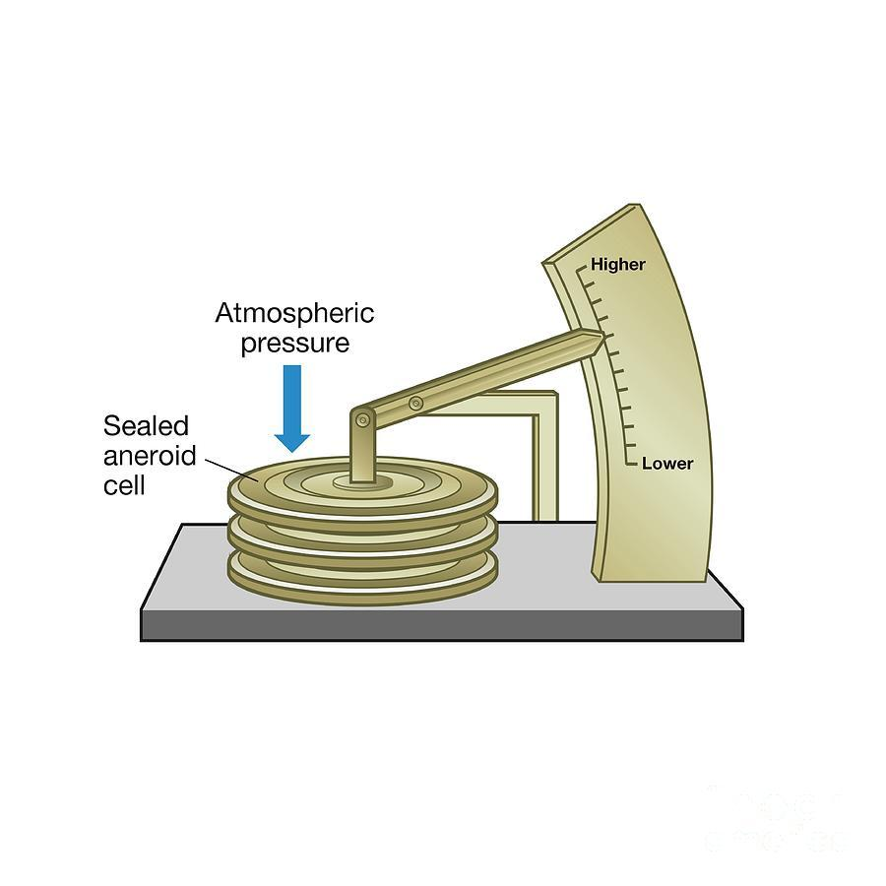
A typical barometer consists of:
- Pressure sensing element
- Display (dial or digital)
- Protective housing
- Calibration mechanism
- Scale or electronic display

Types of Barometers

1. Mercury Barometer
# Source: AI Source: Provided by: [Data Path: Persons Table -> ID Column: 1, Name_En Column: Motasem Essam] -> From: [ChatGPT] on [7/17/2026]
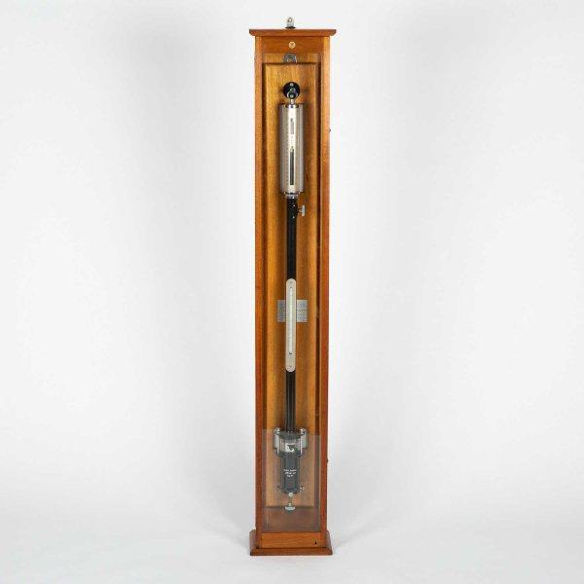
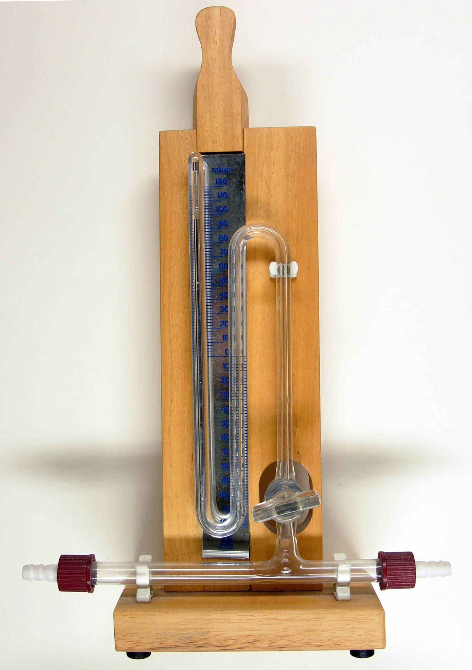
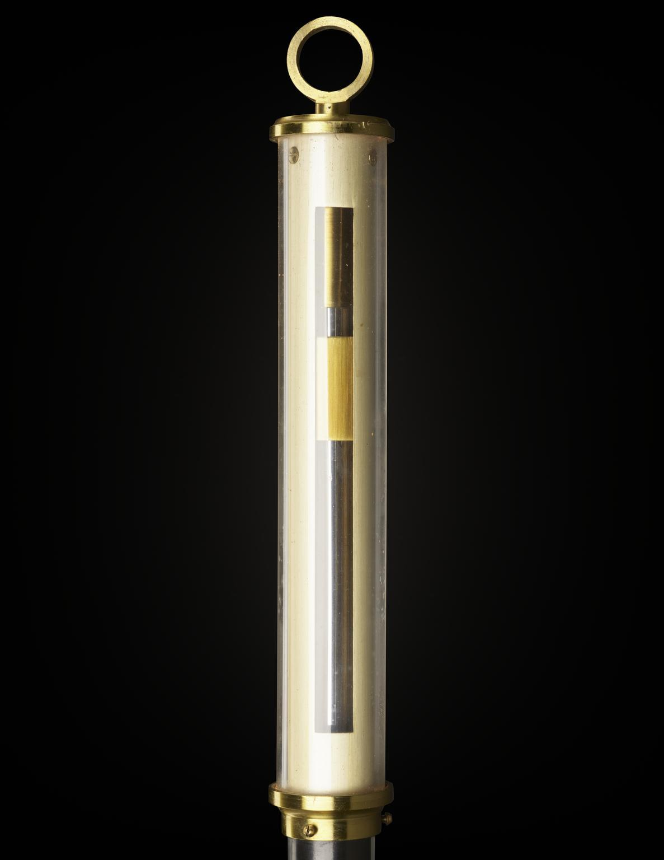
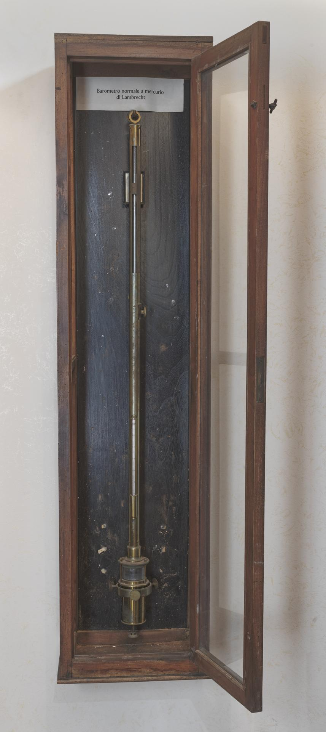
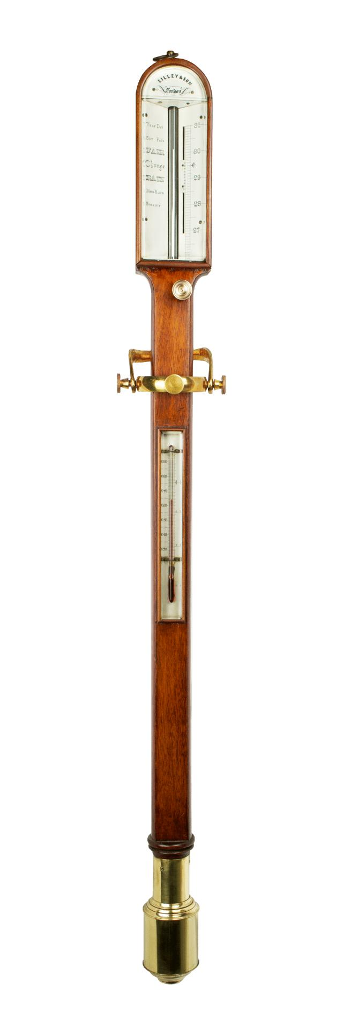
Description
Uses a glass tube filled with mercury. Atmospheric pressure supports the mercury column, and its height indicates atmospheric pressure.
Applications
- Meteorological stations
- Scientific laboratories
- Pressure calibration

2. Aneroid Barometer
# Source: AI Source: Provided by: [Data Path: Persons Table -> ID Column: 1, Name_En Column: Motasem Essam] -> From: [ChatGPT] on [7/17/2026]

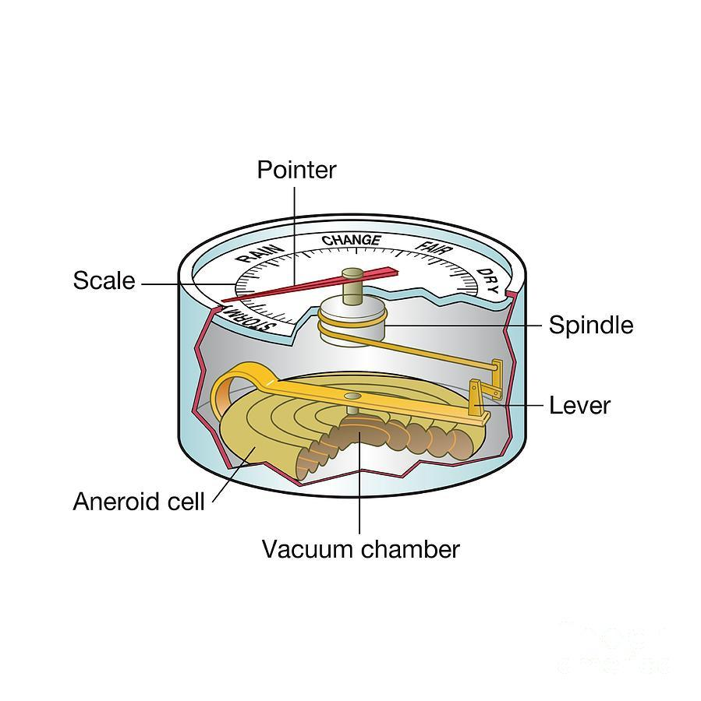
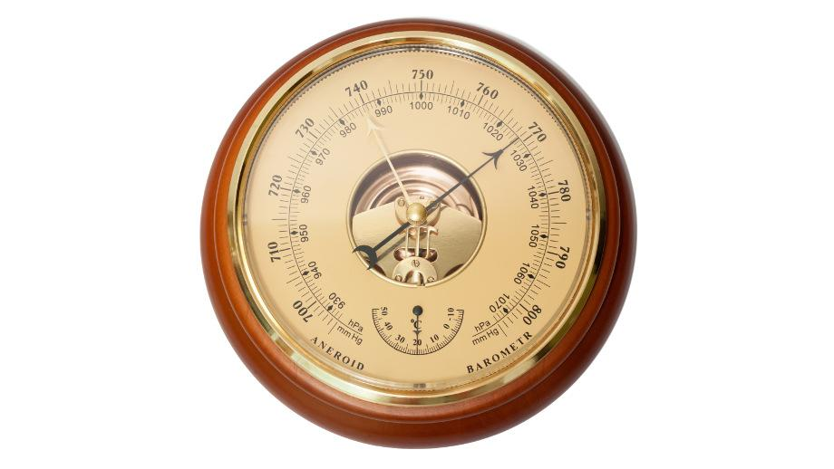
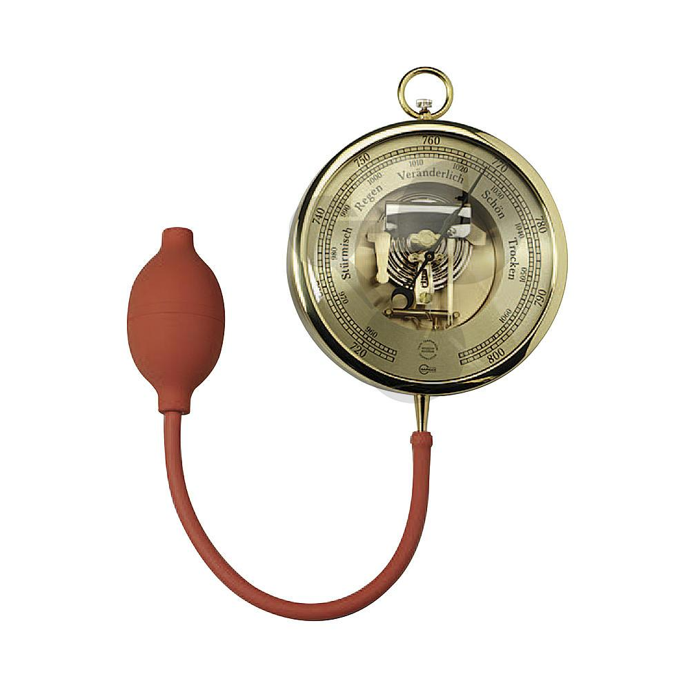
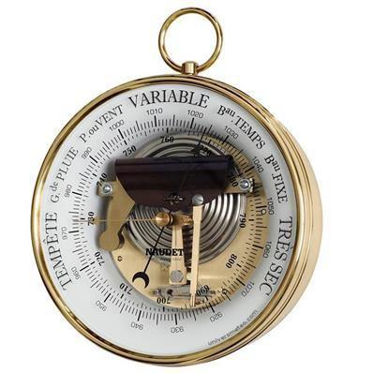
Description
Uses a sealed flexible metallic capsule (aneroid cell) that expands or contracts as atmospheric pressure changes.
Applications
- Home weather stations
- Aviation
- Mountaineering
- Marine navigation

3. Digital Barometer
# Source: AI Source: Provided by: [Data Path: Persons Table -> ID Column: 1, Name_En Column: Motasem Essam] -> From: [ChatGPT] on [7/17/2026]

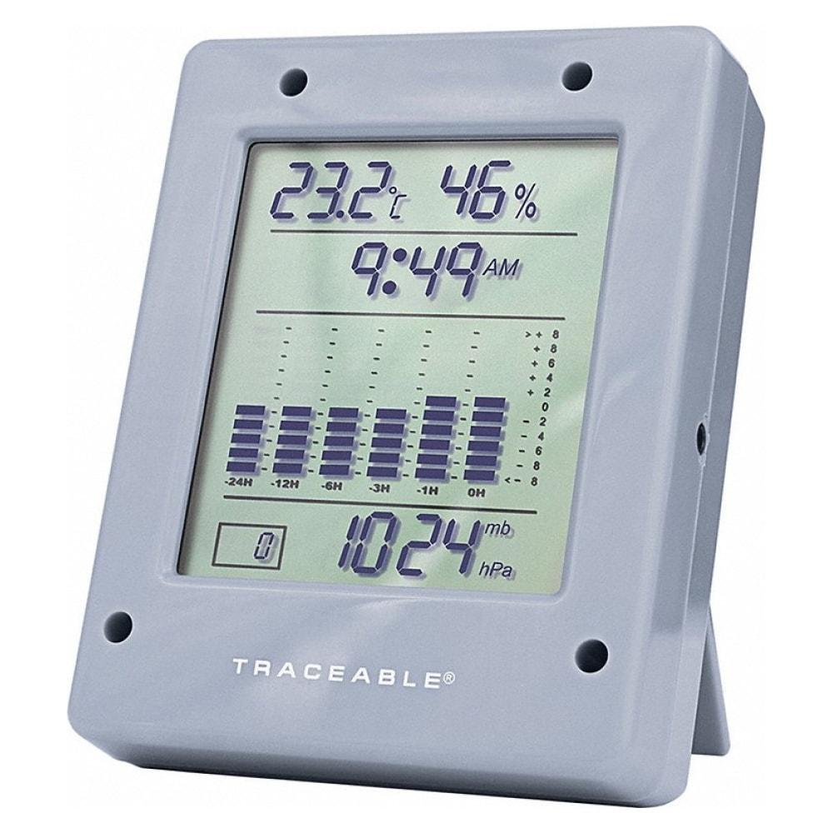
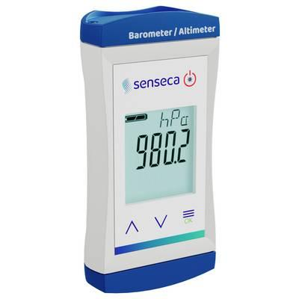
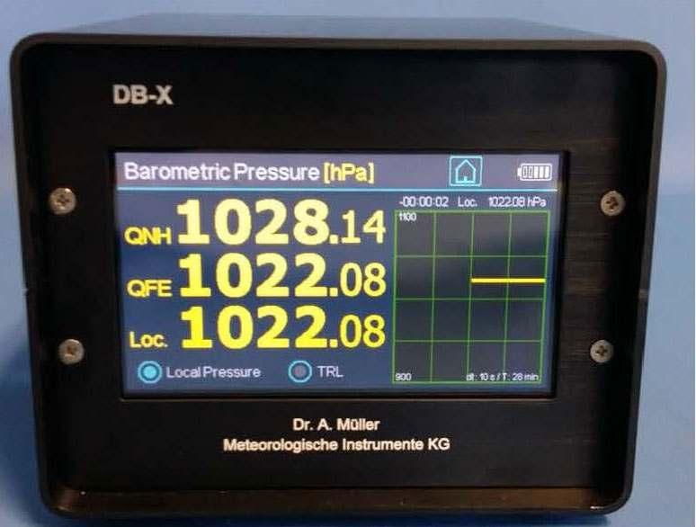
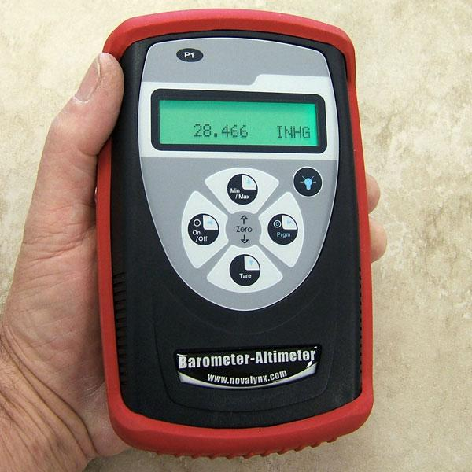
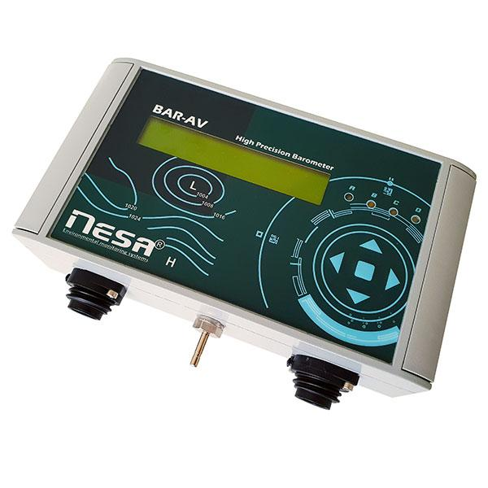
Description
Uses an electronic pressure sensor to measure atmospheric pressure and display the result digitally.
Applications
- Weather stations
- Smartphones
- Environmental monitoring
- Research laboratories

4. Barograph
# Source: AI Source: Provided by: [Data Path: Persons Table -> ID Column: 1, Name_En Column: Motasem Essam] -> From: [ChatGPT] on [7/17/2026]

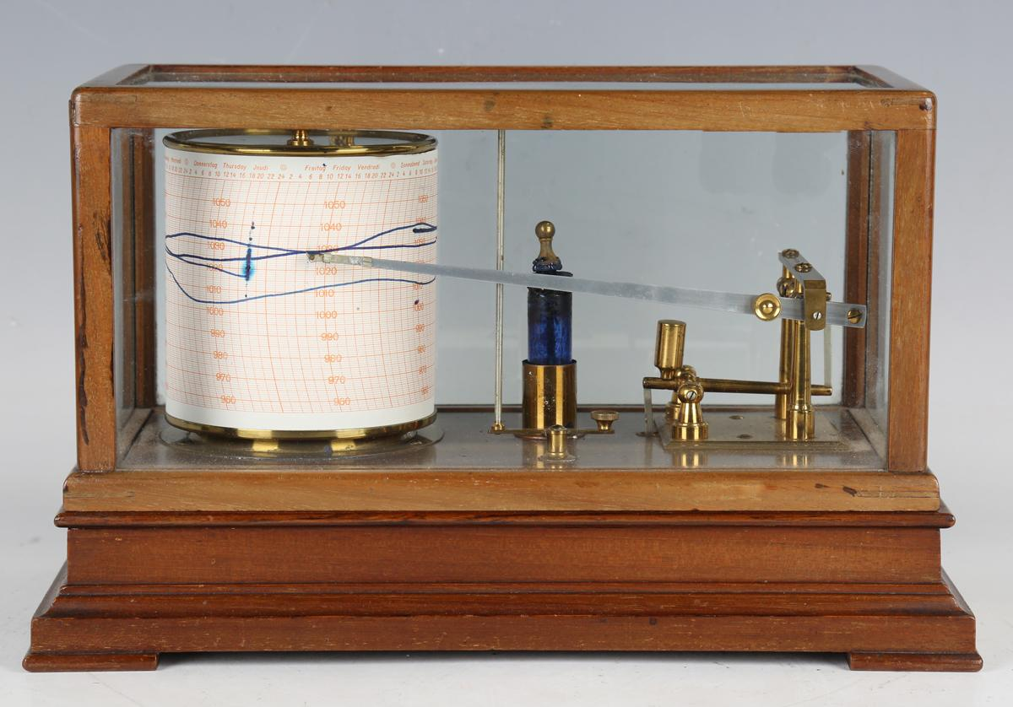
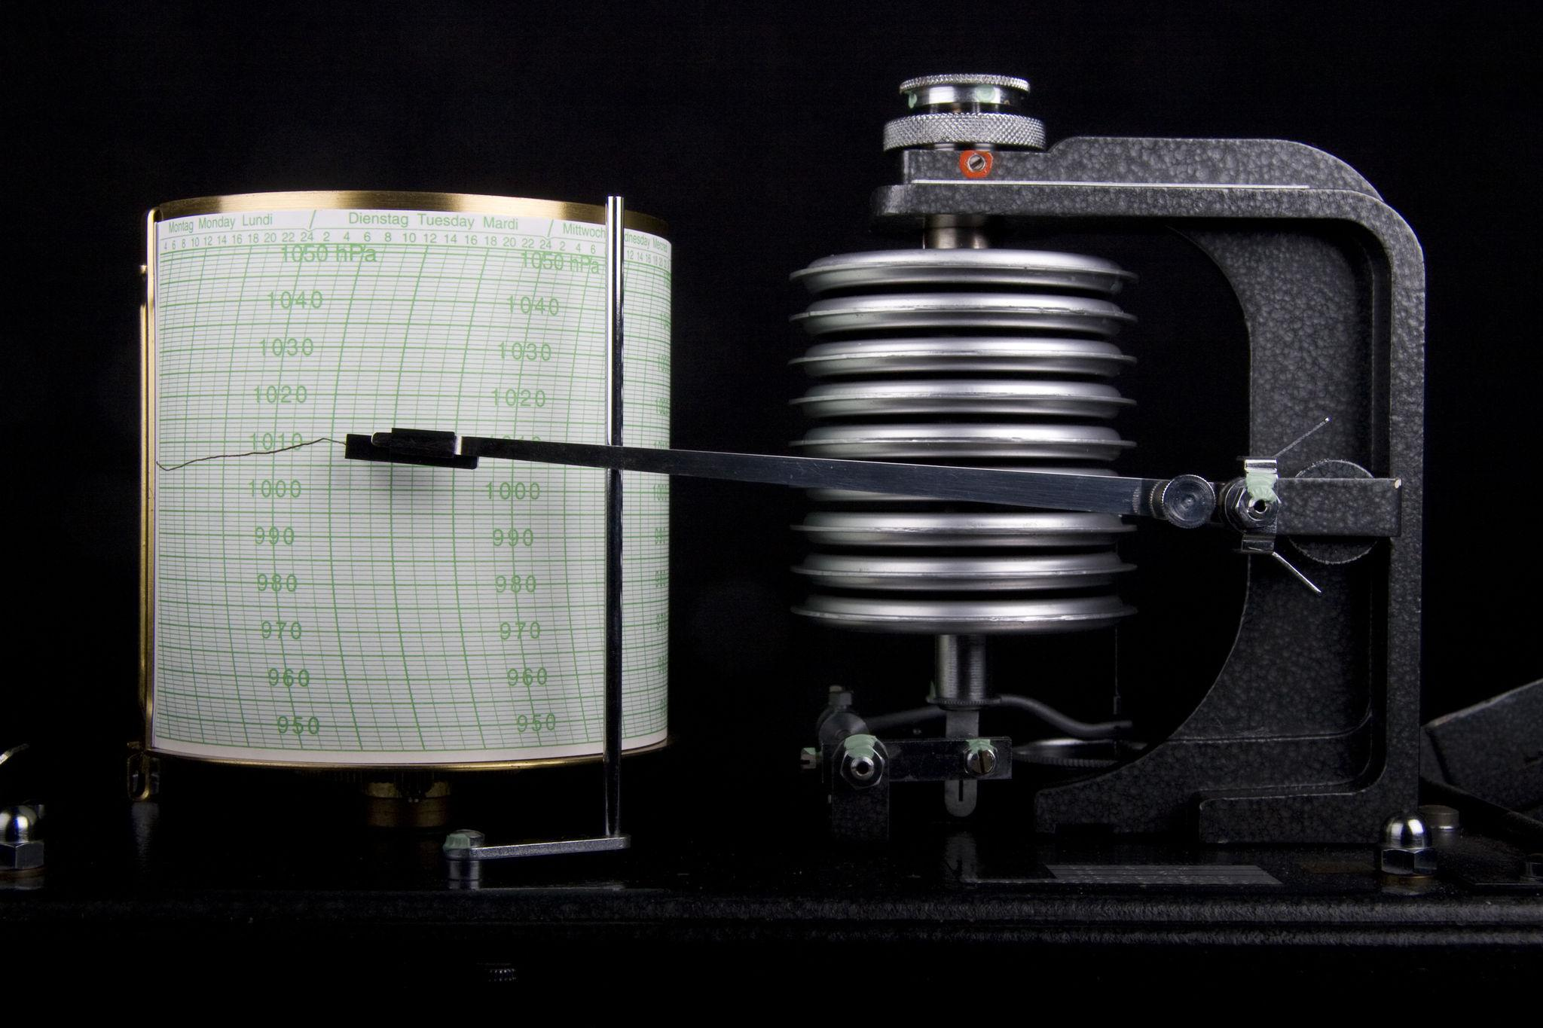
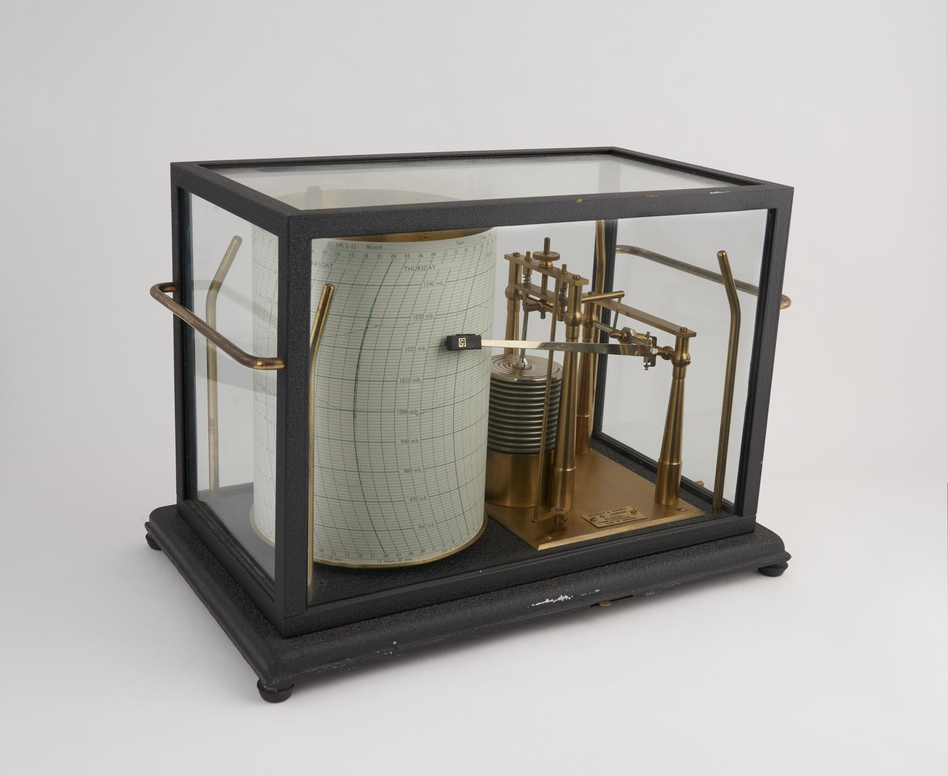
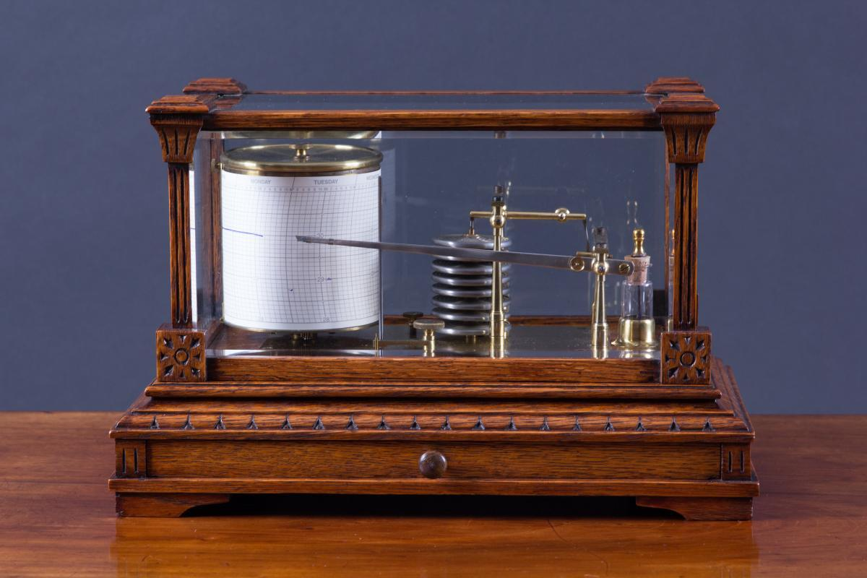
Description
A recording barometer that continuously measures and records atmospheric pressure over time on paper or electronically.
Applications
- Meteorological observatories
- Climate monitoring
- Weather forecasting
- Scientific research

Measuring Units
# Source: AI Source: Provided by: [Data Path: Persons Table -> ID Column: 1, Name_En Column: Motasem Essam] -> From: [ChatGPT] on [7/17/2026]
Barometers commonly display:
- Pascal (Pa)
- Hectopascal (hPa)
- Kilopascal (kPa)
- Millibar (mbar)
- Atmosphere (atm)
- Millimeters of mercury (mmHg)
- Inches of mercury (inHg)

Measuring Range
# Source: AI Source: Provided by: [Data Path: Persons Table -> ID Column: 1, Name_En Column: Motasem Essam] -> From: [ChatGPT] on [7/17/2026]
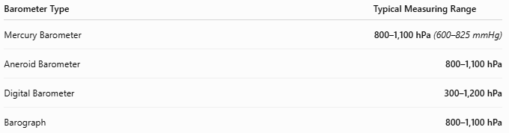
Barometer Type | Typical Measuring Range
Mercury Barometer | 800–1,100 hPa (600–825 mmHg)
Aneroid Barometer | 800–1,100 hPa
Digital Barometer | 300–1,200 hPa
Barograph | 800–1,100 hPa

Resolution
# Source: AI Source: Provided by: [Data Path: Persons Table -> ID Column: 1, Name_En Column: Motasem Essam] -> From: [ChatGPT] on [7/17/2026]
Resolution is the smallest pressure increment displayed.
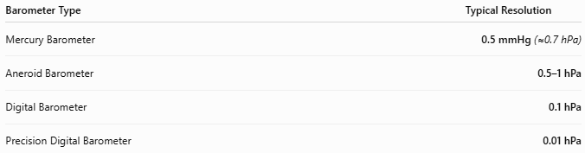
Barometer Type | Typical Resolution
Mercury Barometer | 0.5 mmHg (≈0.7 hPa)
Aneroid Barometer | 0.5–1 hPa
Digital Barometer | 0.1 hPa
Precision Digital Barometer | 0.01 hPa

Accuracy
# Source: AI Source: Provided by: [Data Path: Persons Table -> ID Column: 1, Name_En Column: Motasem Essam] -> From: [ChatGPT] on [7/17/2026]
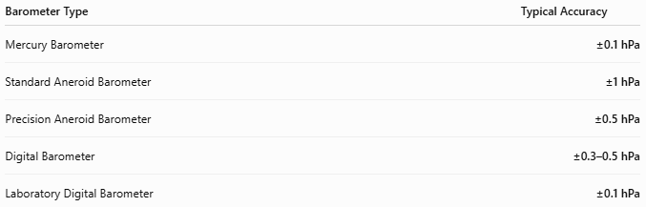
Barometer Type | Typical Accuracy
Mercury Barometer | ±0.1 hPa
Standard Aneroid Barometer | ±1 hPa
Precision Aneroid Barometer | ±0.5 hPa
Digital Barometer | ±0.3–0.5 hPa
Laboratory Digital Barometer | ±0.1 hPa
Notes
- Mercury barometers remain the reference standard for atmospheric pressure calibration.
- Digital barometers generally provide the best combination of accuracy, resolution, and convenience.
- Accuracy depends on calibration, ambient temperature, and sensor quality.

How to Use a Barometer
# Source: AI Source: Provided by: [Data Path: Persons Table -> ID Column: 1, Name_En Column: Motasem Essam] -> From: [ChatGPT] on [7/17/2026]
- Place the instrument in a stable environment.
- Allow it to stabilize.
- Read the atmospheric pressure from the display.
- Record pressure changes over time if monitoring weather.

Applications
# Source: AI Source: Provided by: [Data Path: Persons Table -> ID Column: 1, Name_En Column: Motasem Essam] -> From: [ChatGPT] on [7/17/2026]
Barometers are used in:
- Meteorology
- Weather forecasting
- Aviation
- Marine navigation
- Environmental monitoring
- Scientific laboratories
- Altitude estimation
- Climate research

Advantages
# Source: AI Source: Provided by: [Data Path: Persons Table -> ID Column: 1, Name_En Column: Motasem Essam] -> From: [ChatGPT] on [7/17/2026]
A barometer:
- Measures atmospheric pressure accurately.
- Helps predict weather changes.
- Supports altitude estimation.
- Available in analog and digital forms.
- Requires little maintenance.

Limitations
# Source: AI Source: Provided by: [Data Path: Persons Table -> ID Column: 1, Name_En Column: Motasem Essam] -> From: [ChatGPT] on [7/17/2026]
A barometer:
- Measures only atmospheric pressure.
- Mercury models require careful handling.
- Aneroid mechanisms may drift over time.
- Digital models require battery power.

Sources of Error
# Source: AI Source: Provided by: [Data Path: Persons Table -> ID Column: 1, Name_En Column: Motasem Essam] -> From: [ChatGPT] on [7/17/2026]
Instrument Errors
- Calibration drift
- Sensor aging
- Mercury contamination (mercury models)

User Errors
- Incorrect calibration
- Reading analog scale incorrectly
- Improper installation

Environmental Errors
- Temperature variation
- Mechanical vibration
- Rapid altitude changes

Comparison with Other Pressure Measuring Instruments
# Source: AI Source: Provided by: [Data Path: Persons Table -> ID Column: 1, Name_En Column: Motasem Essam] -> From: [ChatGPT] on [7/17/2026]
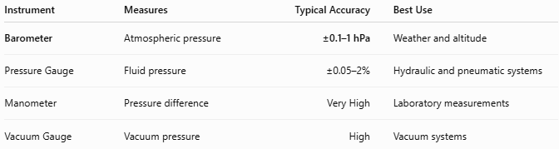
Instrument | Measures | Typical Accuracy | Best Use
Barometer | Atmospheric pressure | ±0.1–1 hPa | Weather and altitude
Pressure Gauge | Fluid pressure | ±0.05–2% | Hydraulic and pneumatic systems
Manometer | Pressure difference | Very High | Laboratory measurements
Vacuum Gauge | Vacuum pressure | High | Vacuum systems

Care and Maintenance
# Source: AI Source: Provided by: [Data Path: Persons Table -> ID Column: 1, Name_En Column: Motasem Essam] -> From: [ChatGPT] on [7/17/2026]
To maintain accuracy:
- Keep the instrument clean.
- Avoid impacts.
- Calibrate periodically.
- Protect mercury models from breakage.
- Replace batteries in digital models as needed.

Common Mistakes
# Source: AI Source: Provided by: [Data Path: Persons Table -> ID Column: 1, Name_En Column: Motasem Essam] -> From: [ChatGPT] on [7/17/2026]
- Using an uncalibrated instrument.
- Reading the analog scale incorrectly.
- Exposing the instrument to excessive vibration.
- Ignoring temperature effects.

Key Points
# Source: AI Source: Provided by: [Data Path: Persons Table -> ID Column: 1, Name_En Column: Motasem Essam] -> From: [ChatGPT] on [7/17/2026]
- A Barometer measures atmospheric pressure.
- Common types:
  - Mercury Barometer
  - Aneroid Barometer
  - Digital Barometer
  - Barograph
- Common units:
  - hPa
  - mbar
  - mmHg
  - inHg
  - atm

Conclusion
# Source: AI Source: Provided by: [Data Path: Persons Table -> ID Column: 1, Name_En Column: Motasem Essam] -> From: [ChatGPT] on [7/17/2026]
A Barometer is an essential instrument for measuring atmospheric pressure and is widely used in meteorology, aviation, environmental science, and altitude measurement. Whether using a mercury, aneroid, digital, or recording (barograph) design, barometers provide reliable pressure measurements that help forecast weather, monitor environmental conditions, and support scientific research.

